Isolation Forest: A Detailed Explanation with Code & Diagrams
🚀 Introduction
Isolation Forest (iForest) is an unsupervised machine learning algorithm used for anomaly detection. It is particularly useful for detecting outliers in high-dimensional datasets.
Isolation Forest is based on decision trees and is highly efficient compared to traditional methods like K-Means, PCA, or DBSCAN.

🔍 Why Use Isolation Forest?
✅ Fast & Scalable: Works well with large datasets.
✅ Handles High Dimensions: Unlike distance-based methods (e.g., K-Means).
✅ Robust to Outliers: Specifically designed to isolate anomalies.
✅ Unsupervised Learning: No labeled data required.

1️. How Does Isolation Forest Work?
Isolation Forest works differently than traditional anomaly detection techniques. Instead of profiling normal points, it isolates anomalies by randomly selecting features and splitting values.
🔹 Key Idea: Isolation through Recursive Splitting
- Step 1: Select a random feature from the dataset.
- Step 2: Select a random split value between min and max of the chosen feature.
- Step 3: Split the data into two branches (left & right).
- Step 4: Repeat until each point is isolated in its own node.
- Step 5: The depth of the tree is recorded.
🔹 Why Does This Work?
- Outliers get isolated faster!
- Anomalies are few and far from the dense cluster of normal points, so they require fewer splits to be isolated.
- Normal points require more splits (higher depth) since they are densely packed.
2️. Diagram: Isolation Process
🔍 Concept of Isolation Forest
🔹 Step 1: Randomly select features.
🔹 Step 2: Randomly split data points.
🔹 Step 3: Repeat until isolation is achieved.
mathematica
CopyEdit
Root Node
/ \
Feature 1 < 5 Feature 2 > 3
/ \ / \
Normal Outlier Normal Normal
👉 Outliers get isolated with fewer splits (lower depth).

3️. Understanding Anomaly Scores in Isolation Forest
🔹 The "Anomaly Score" formula:
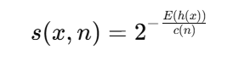
Where:
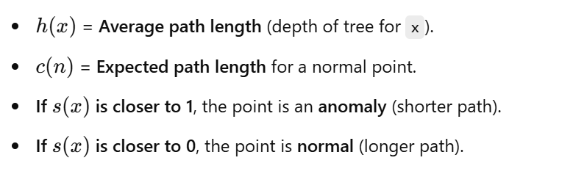👉 Interpretation
- Low anomaly score (< 0.5) → Normal data point
- High anomaly score (> 0.7) → Likely an anomaly

4. Comparing Isolation Forest with Other Methods
Method | Best Use Case | Complexity |  | Handles High-Dimensions?
Isolation Forest | Outlier detection in large datasets | Fast (O(n)) | ✅ Yes
Z-Score Method | Simple outlier detection (univariate) | Medium | ❌ No
DBSCAN | Anomaly detection in clusters | Slow (O(n²)) | ✅ Yes
PCA | Outliers in high-dimensional data | Medium | ✅ Yes
🔹 When to use Isolation Forest?
- When you have high-dimensional data.
- When you need fast anomaly detection.
- When you want an unsupervised approach (no labels needed).

5. Summary
✅ Isolation Forest isolates anomalies faster than normal points.
✅ It uses random feature splits to isolate points.
✅ Shorter paths → Outliers, Longer paths → Normal points.
✅ Works well for high-dimensional datasets.
✅ Anomaly detection applications: Fraud, Network Intrusion, Industrial Faults.

